**CSA1312-THEORY OF COMPUTATION**

M.Akhil

192210015

1.Design DFA using simulator to accept the input string “a” ,”ac”,and ”bac”.

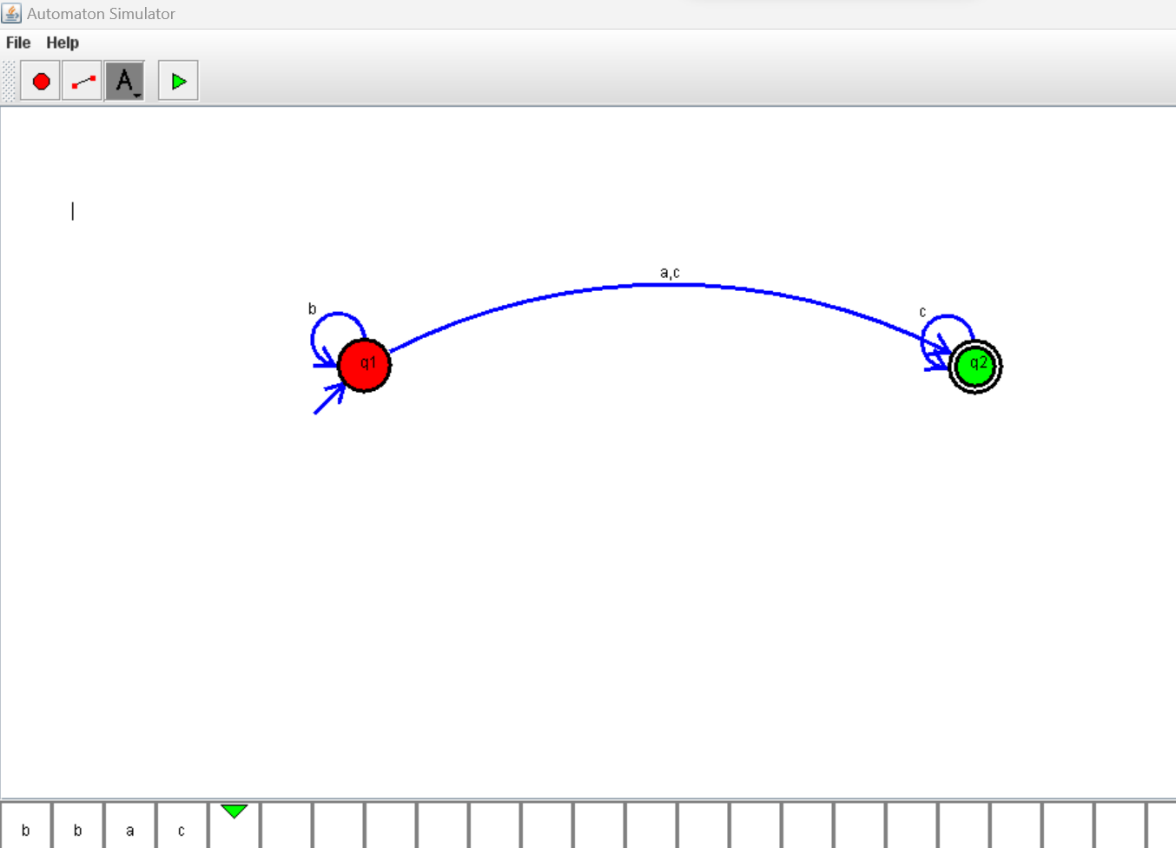

2. Design DFA using simulator to accept even number of a’s.

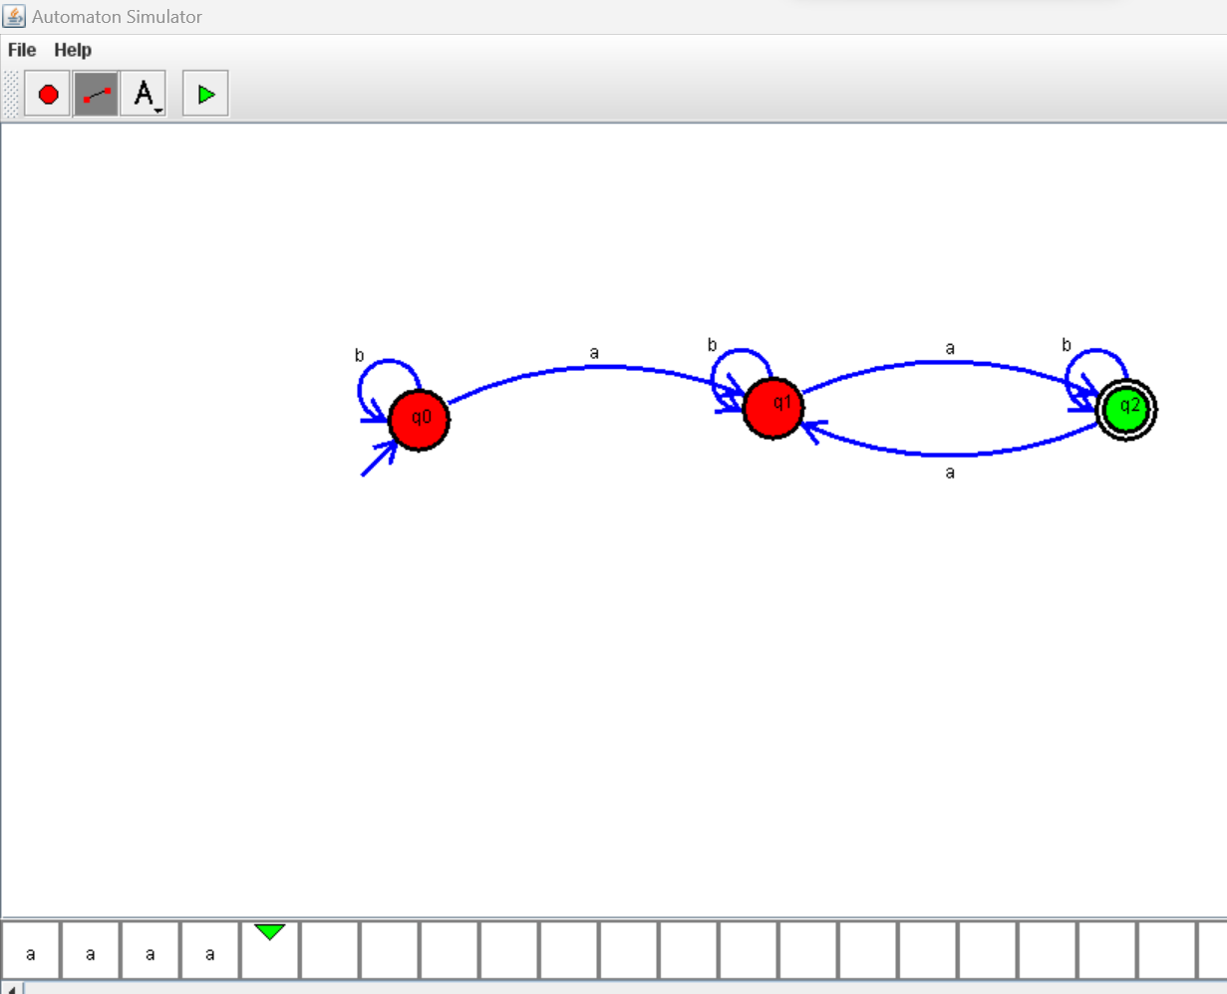

3.Design DFA using simulator to accept odd number of a’s

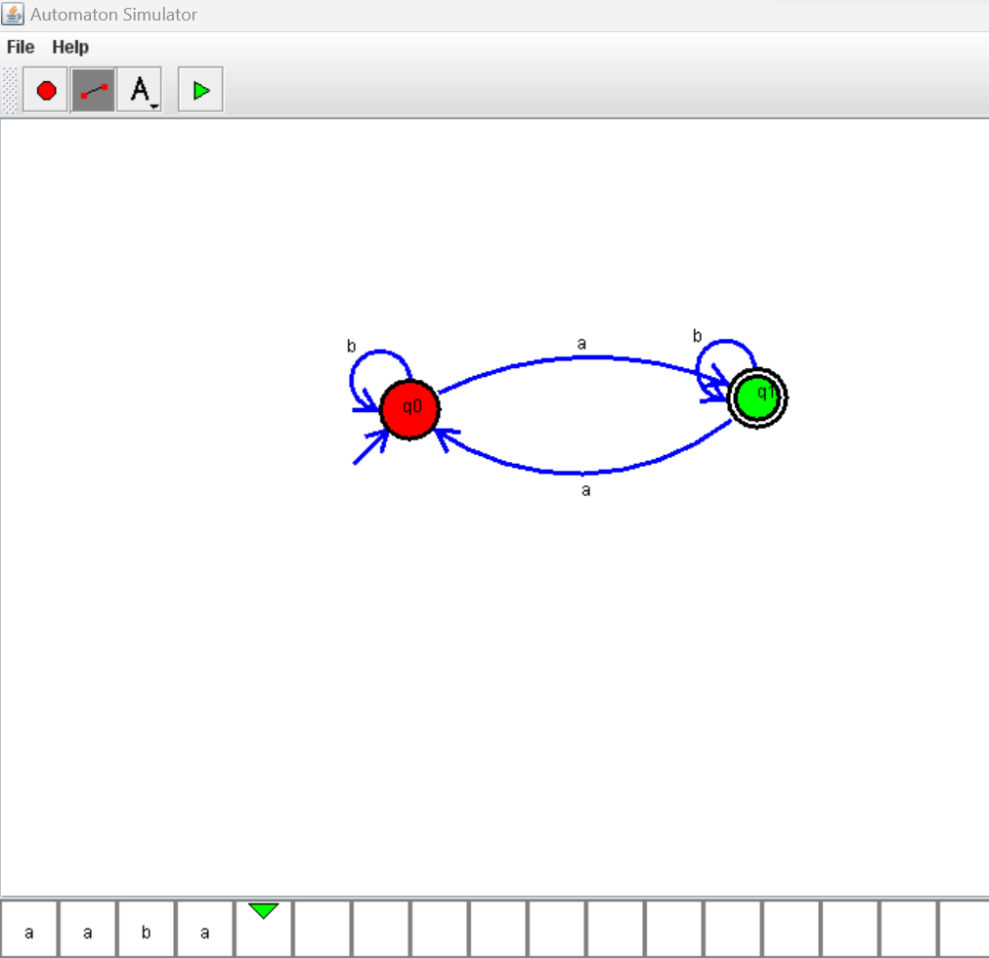

4.Design DFA using simulator to accept the string the end with ab over set {a,b)

W= aaabab

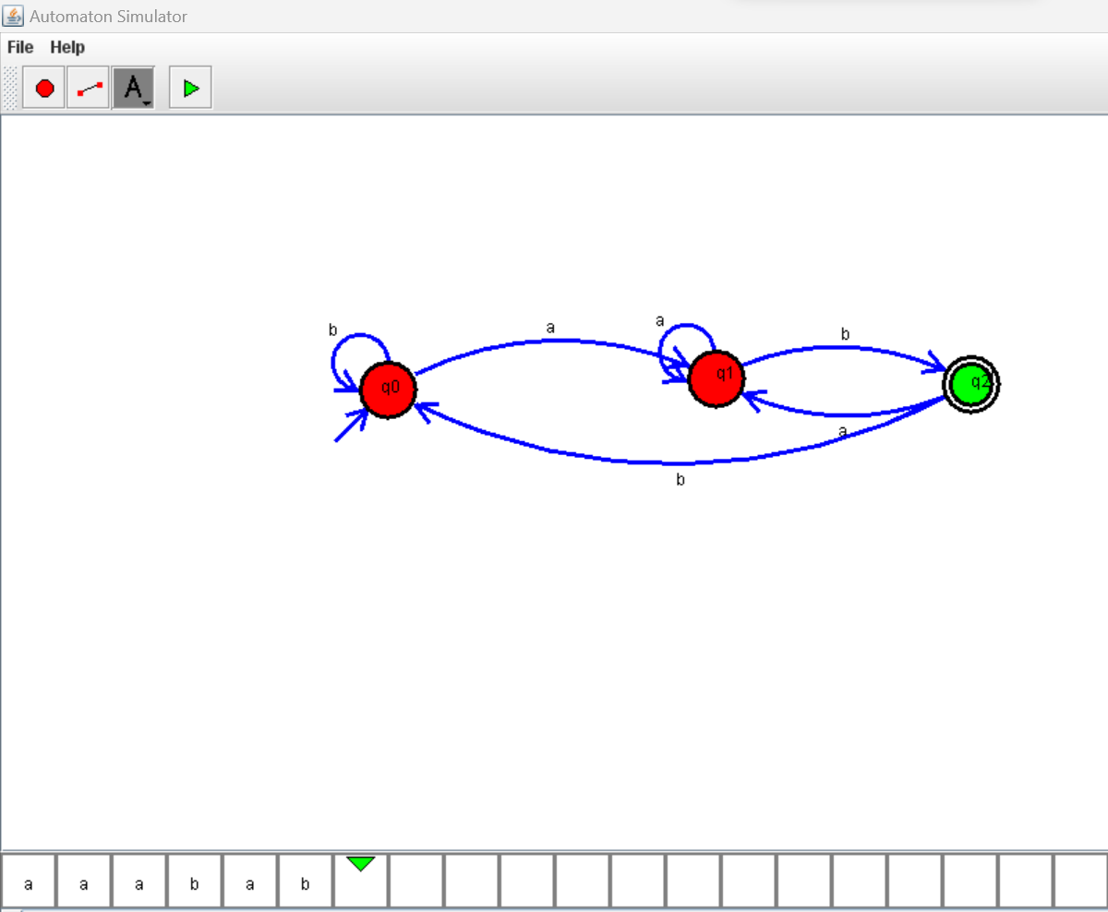

5.Design DFA using simulator to accept the string having ‘ab’ as substring over the set {a,b}

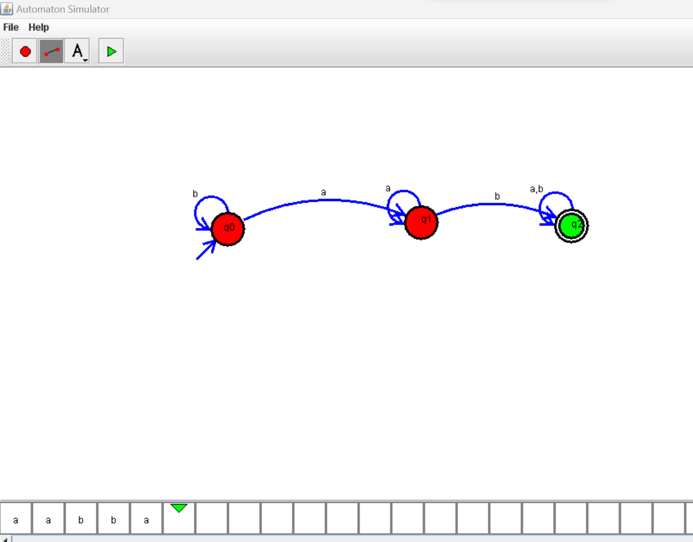

6. Design DFA using simulator to accept the string start with a or b over the set {a,b}

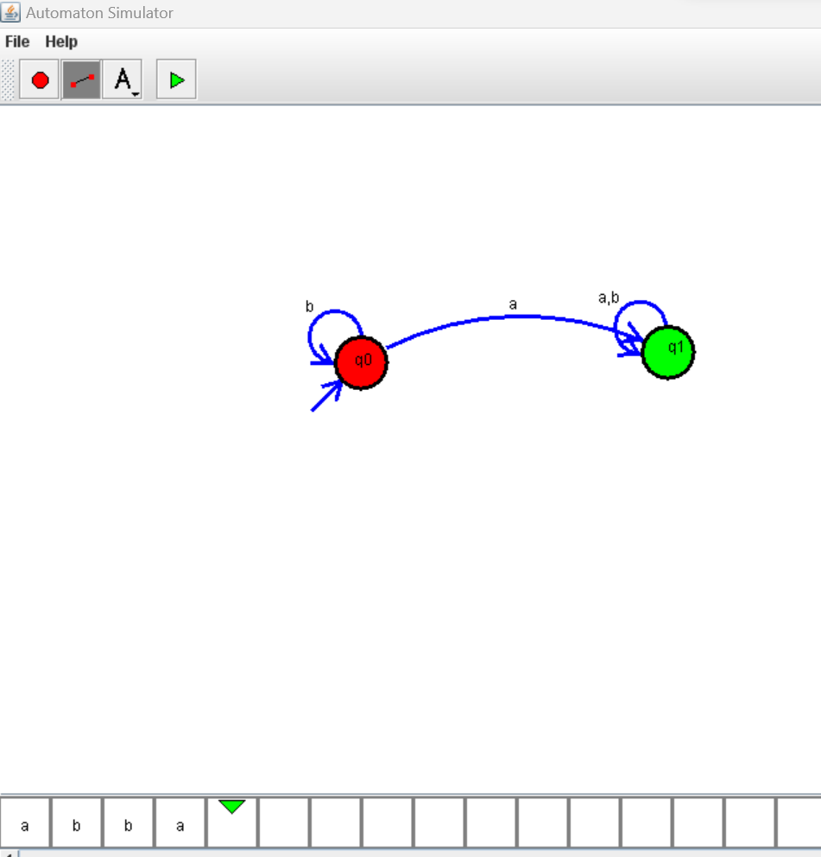

7. Design DFA using simulator to accept the input string “bc” ,”c”,and ”bcaaa”.

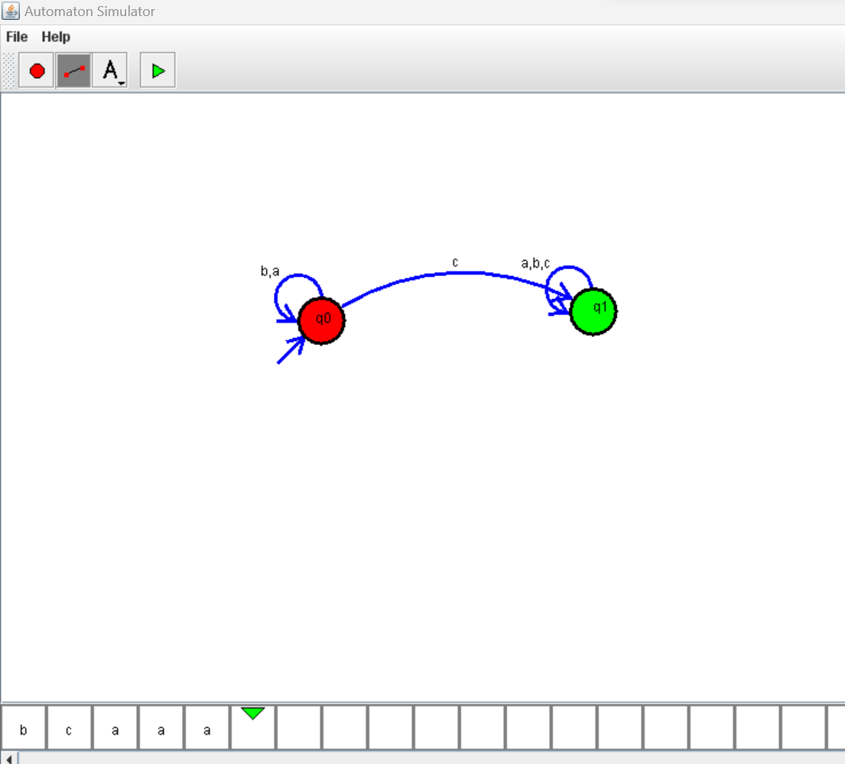

8.Design DFA using simulator to accept the string the end with ab over set {a,b)

W= abbaabab.

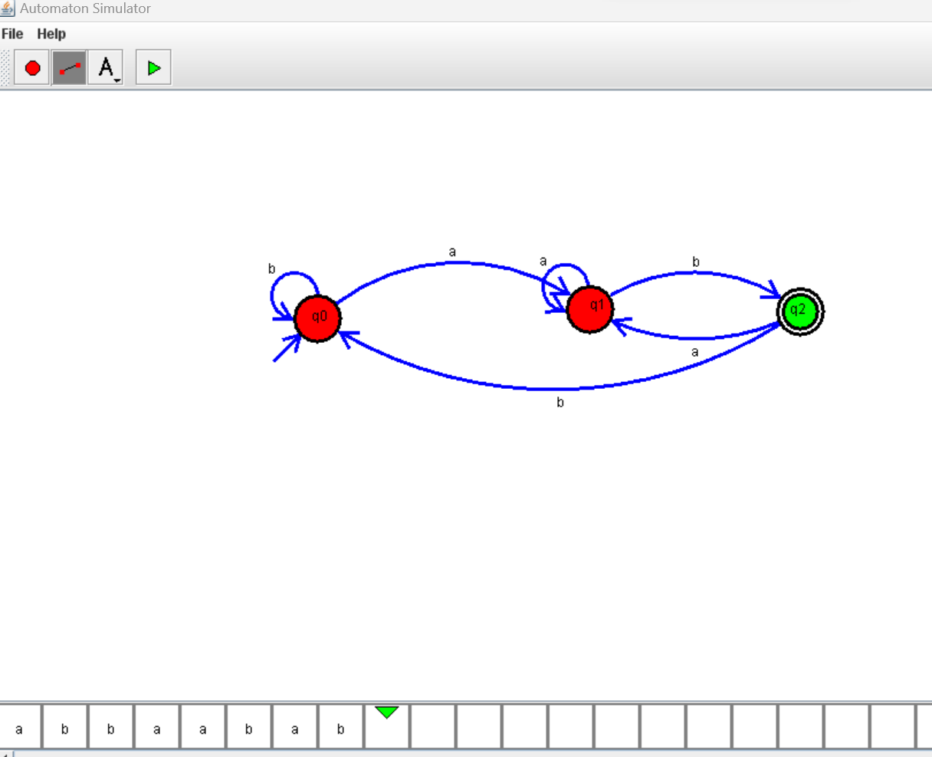

9.Design DFA using simulator to accept the string having ‘abc’ as substring over the set {a,b,c}

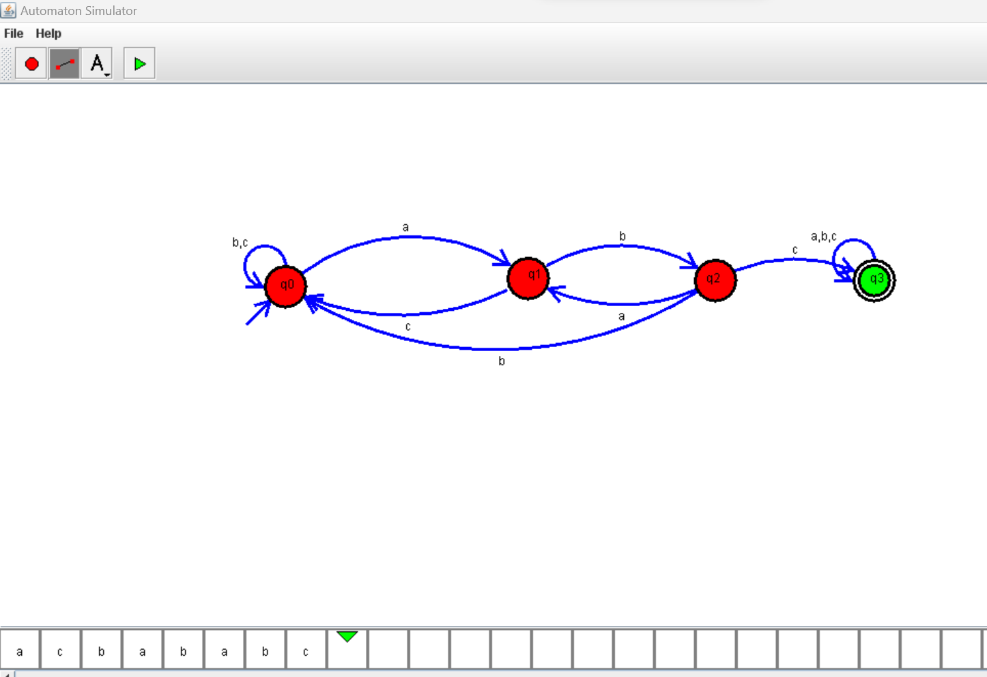

10. Design DFA using simulator to accept even number of c’s over the set {a,b,c}

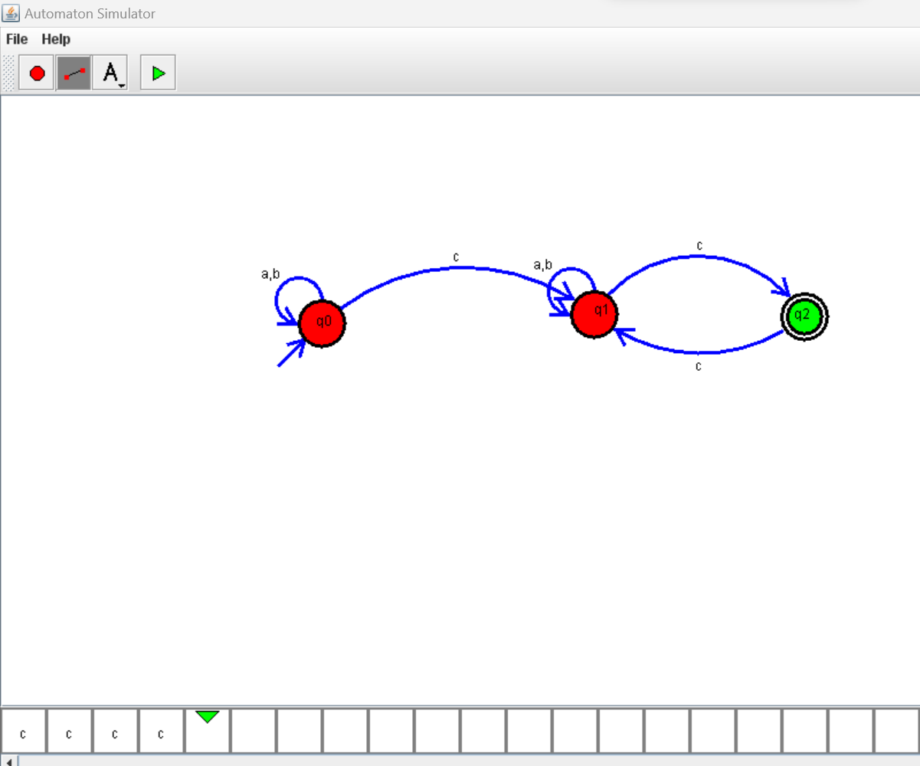

11.Design DFA using simulator to accept strings in which a’s always appear tripled over input {a,b}

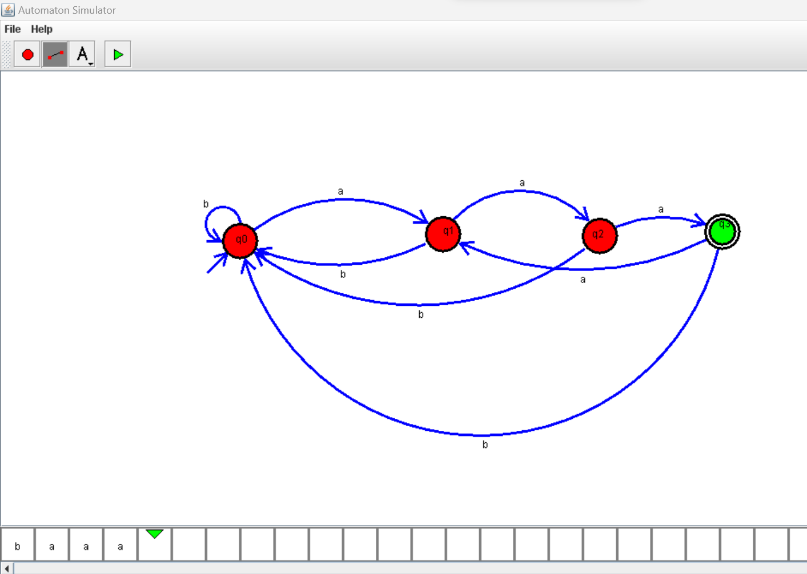

1. Design DFA using simulator to accept the string the end with abc over set {a,b,c)

W= abbaababc

